**Drop It Low**

**RULES:** Practical Shooting Handbook, Latest Edition **COURSE DESIGNER:** Ike Starnes

|  |  |
| --- | --- |
| **START POSITION: See written stage briefings.** | |
| **STAGE PROCEDURE**  Engage targets from within the shooting area. | **SCORING**  **SCORING:** Comstock, 24 rounds, 120 points  **TARGETS:** 12 USPSA paper targets  **SCORED HITS:** 2 Best hits per target will be scored  **START-STOP:**  Audible - Last shot  **PENALTIES:** Per current USPSA Rules |

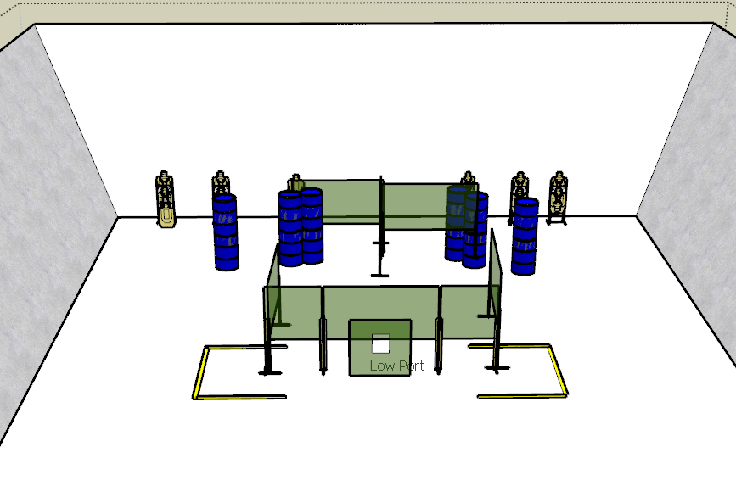

**Written Stage Briefings:**

**Stage 1 –** is a 24-round, 120 point, Comstock Long Course. There are 12 USPSA targets and the best 2 hits per target will be scored.

**Handgun start position** is standing anywhere inside the shooting area with wrists below belt. The handgun is loaded and holstered.

**PCC start position** is standing anywhere inside the shooting area with stock on shoulder and strong hand wrist below belt, muzzle pointed downrange. PCC is loaded with stock on belt.

On the audible start signal, engage targets from within the shooting area.

**Stage 2 –** is a 24-round, 120 point, Comstock Long Course. There are 12 USPSA targets and the best 2 hits per target will be scored.

**Handgun start position** is standing inside the shooting area with hands touching marks. The handgun is loaded and holstered.

**PCC start position** is standing inside the shooting area muzzle touching mark. PCC is loaded with stock on belt.

On the audible start signal, engage targets from within the shooting area.

**Stage 3 –** is a 24-round, 120 point, Comstock Long Course. There are 12 USPSA targets and the best 2 hits per target will be scored.

**Handgun start position** is standing completely outside the shooting area. The handgun is unloaded and holstered.

**PCC start position** is standing completely outside the shooting area with muzzle pointed downrange. PCC is unloaded with stock on belt.

On the audible start signal, engage targets from within the shooting area.